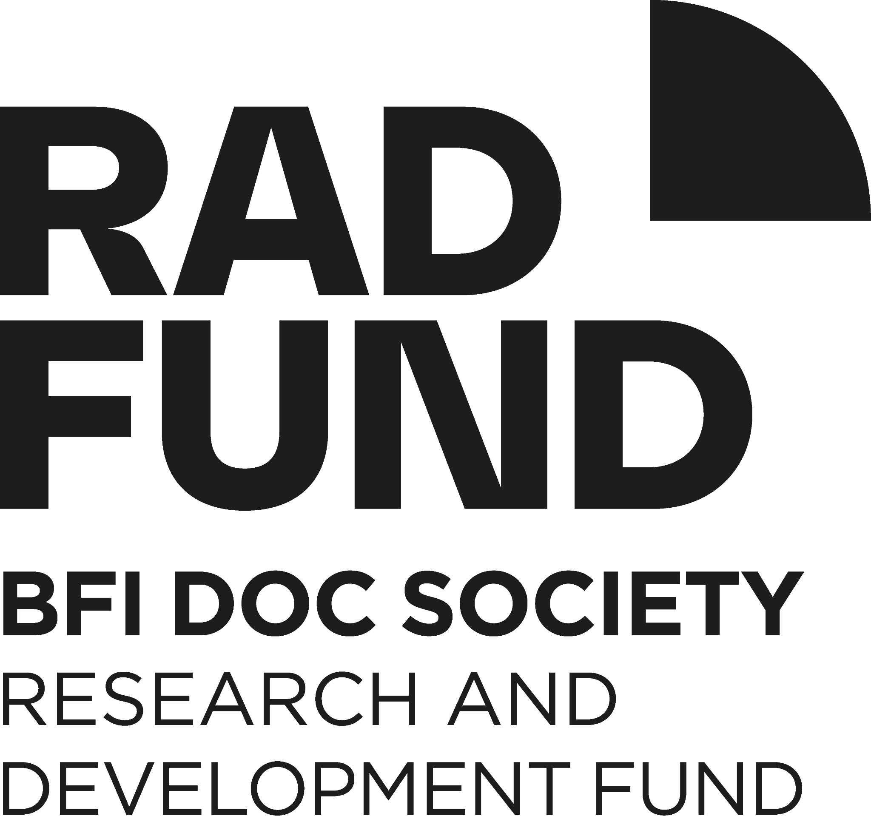

BFI DOC SOCIETY RAD (RESEARCH AND DEVELOPMENT) FUND
FREQUENTLY ASKED QUESTIONS

I’m developing a feature documentary. Should I apply for the BFI Doc Society Features Fund or for the RAD Fund?

Whilst you can apply for the BFI Doc Society Features Fund at any project stage including development, the RAD fund specifically supports the early stages of research and development on a feature length film or nonfiction immersive project of any length.

RAD supports the progression from initial idea to having dynamic and persuasive written materials that can be used to seek support for later stages of development, pre-production or production. The RAD fund supports filmmakers who are unable to access commercial financing, to take the time required to actively explore and develop their project(s).

If you already have a completed pitch deck/equivalent format for immersive projects, you are not eligible for the RAD fund, but would be able to consider the guidelines and eligibility criteria for an application to the BFI Doc Society Features Fund.

RAD Funding is intended to stimulate new approaches and stories for non-fiction projects. It therefore doesn’t support projects that have already attracted other investment.

If you have made more than two feature documentaries as a Director, you cannot apply for the RAD fund, but you are eligible to apply for development funding through BFI Doc Society Features Fund.

Do I need a producer to apply?

No. You can apply to the RAD fund as a first or second time feature documentary director without a producer.

Do I need a production company to apply?

Applicants can apply either as an individual or through their UK registered company.

What level of experience is required to be eligible for the RAD fund?

If applying as a director with a single project, applicants should be working on their first or second documentary feature film.

If applying as a producer with more than one project, applicants should be emerging or mid-career and made one or more feature documentaries, but not more than three.

Directors and producers are expected to be able to demonstrate a strong creative track record in documentary film or immersive work (as applicable) or if they come from a different creative background, a track record in other creative work.

How much money can I apply for?

The amount that you are applying for must be no less than £3,000 and no more than £5,000 for a single project, and no less than £3,000 and no more than £10,000 within a single application covering multiple projects.

How does a producer apply with multiple projects?
If you are a producer seeking early development support for more than one project simultaneously you will need to complete an application form per project and enter the title of the connected application in the appropriate question box at the top of the application form. We recommend you do not leave a period of more than two days between each connected application, to ensure the applications are considered together.

How long does it take to get a decision?

When you submit your application you will receive a confirmation email in receipt of your application. From the date of this confirmation onwards, the decision making process may take up to 12 weeks.

Who will read my application?

Your application will be considered against the assessment criteria set out in the fund guidelines by at least two internal reviewers, including the Head of the Fund (or, in their absence, a delegated Doc Society Executive Director). Where required an independent external reader may be asked to provide an additional perspective. We may share parts of your application with other Doc Society teams, the BFI, or external readers, to help support the assessment.

I don’t know if my project qualifies for the BFI Cultural Test, where can I get guidance?

If you have a question about the BFI Cultural Test that isn’t covered in the BFI website, please contact the BFI Certification Unit on +44 (0)20 7173 3214 or email certifications@bfi.org.uk

What do you offer people who have specific access needs?
The BFI Doc Society is committed to making its funding accessible to all. TAPE Community Film and Music will be providing individually tailored support for applicants with access needs. Find all the details on what support you can receive and how to get the help required to make an application in this Word document.

How can I get in touch with BFI Doc Society?

Contact BFI Doc Society Production Coordinator Kit on hello@docsociety.org or register for an online 1-2-1 advice session (hosted regularly on a Thursday) with a member of the BFI Doc Society team here.

Is your question still not answered? Please email hello@docsociety.org and we will collate further FAQs and add to this document in the future.

